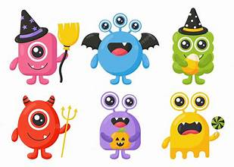 | Monday | Tuesday | Wednesday | Thursday | Friday
Storytime: | Room on the Broom  Obj: Exploration | Theres a Monster in Your Book!  Obj: Follow storyline | How to catch a Monster  Obj: Follow Storyline | The Gruffalo  Obj: Storytime | Monster ABCs  Obj: Learning the Alphabet
Sensory Activities: | If You’re a Monster and You Know It  Obj: Cognitive stimulation | 5 Little Monsters Song with Hand Motions  Obj: Participation | Monster Rescue  Obj: Problem-solving | Looking for Monsters  Obj: Problem solving | Making Music  Obj: Fine and Large motor
Art Choice: | Monster Collage  Obj: Personal project | Watercolor Monsters  Obj: Explore different media | Finger Painting  Obj: Finger strength | Monster Drawings  Obj: Explore media tools | ABC Stamps  Obj: Follow directions
Motor Activity: | Monster Faces  Obj: Freedom of expression | Monster Crawl  Obj: Large Motor | Monster Yoga  Obj: Problem solving | Monster Pokey  Obj: Following along | Monster Mash Dance Party  Obj: Large Motor
STEM: | Tower Building  Obj: Experimentation | Star Connectors  Obj: Critical thinking | Bristle Blocks  Obj: Problem solving | What’s your Favorite Monster?  Obj: Graphing | Counting Monsters  Obj: Number association

Monsters!

Week of October 20th-24th

