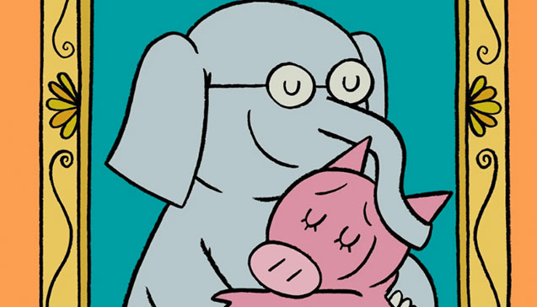
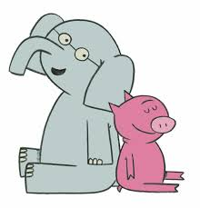
Piggie and Gerald
This Photo by Unknown Author is licensed under CC BY-SA-NC
This Photo by Unknown Author is licensed under CC BY-SA-NC
Rainbow Lesson Plans for February 23-27, 2026

 | Monday | Tuesday | Wednesday | Thursday | Friday
Concept | Piggie and Gerald are the main characters in the Elephant and Piggy Books by Mo Wiliams. | They are best friends. | Piggie and Gerald care about how each other are feeling. | They share what they have with each other. | Piggie and Gerald play with each other.
Circle Time and Story  Welcome Songs  Name/Letter Recognition Game | Book: A Big Guy Took My Ball! By Mo Williams | Book: I’m Invited to a Party By Mo Williams | Book: My Friend is Sad By Mo Williams | Book: Should I share My Ice Cream? By Mo Williams | Book: Are You Ready to Play Outside? By Mo Williams
Discovery Activities | Magnet Tiles  Puzzles | Legos  Natural Wood Blocks | Chalkboards  Waffle Blocks | Bristle Blocks  Puzzles | Stencils and Colored Pencils  Magnet Tiles
Art | Pink and Gray Paintings | Piggy and Gerald Headband | Gerald Collage | Paper Plate Piggy | Piggy and Gerald Drawings
Music Interaction and Group Games | Song: Your Friends Are My Friends | Song: We’re Going to a Party | Song: If You’re Happy and You Know It | Song: Happy Face | Song: Dance Around

