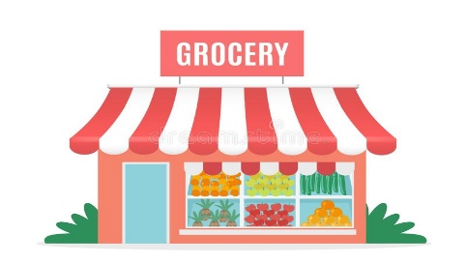 | Monday | Tuesday | Wednesday | Thursday | Friday
Storytime: | Maisy Goes Shopping  Obj: Connection to real world | At the Supermarket  Obj: Exploration | We’re Going to The Farmers’ Market  Obj: Connection to real world | Max Explains Everything: Grocery Store Expert  Obj: Follow storyline | Max Goes to the Grocery Store  Obj: Exploration
Sensory Activities: | What’s That Sound?  Obj: Guess the sound | Shopping Cart Song with Instruments  Obj: Cognitive stimulation | Scrub Those Veggies  Obj: Problem-solving skills | Cutting Veggies & Fruits (with plastic butter knife)  Obj: Safety Skills | At the Grocery Store Song with Instruments  Obj: Cognitive stimulation
Art Choice: | Donut Friends  Obj: Personal project | Fingerprint Blueberries  Obj: Explore media tools | Paper Plate Pizza  Obj: Invitation to create | Placemats  Obj: Choosing favorite foods | Melted Ice Cream  Obj: Explore media tools
Motor Activity: | Decorate Store Sign for Grand Opening  Obj: Problem-solving | Put Groceries Away  Obj: Spatial awareness | Bagging Groceries  Obj: Hand dexterity | Grocery Cart Races  Obj: Hand-eye coordination | Build Our Own Grocery Store  Obj: Class Project
STEM: | What’s Your Favorite Fruit?  Obj: Graphing | Which Weighs More?  Obj: Intro to Estimation | What’s Your Favorite Vegetable?  Obj: Graphing | Measure Containers  Obj: Measuring | What’s Your Favorite Ice Cream?  Obj: Graphing

